Social Studies 11
World War One Unit Project

Select ONE topic from ONE of the following areas of interest:

PEOPLE
General Byng Billy Bishop Nellie McClung
General Currie Robert Borden Sam Hughes

EVENTS
Halifax Explosion Ypres Passchendaele
Somme Vimy Ridge Trench Warfare

WEAPONS
Airplane Ross Rifle Tank
Submarine Gas Artillery

ISSUES
Vote for Women (Suffrage) Conscription
Life on the Homefront War Measures Act

Project Aspects:

- Research: Use at least THREE different sources. When taking notes, use headings for the material, write in point form and identify sources.
- Visuals: A combination (at least three) of various visuals related to your topic of choice. Be sure to label your visuals and provide a brief description.
- Bibliography: A properly formatted bibliography of at least three sources.
- Summary: Use your research to create a 200-word paragraph that summarizes your topic. Concentrate your paragraph on answering: who, what, where, when, why and how in relation to your topic. What was the significance of your topic to WWI?
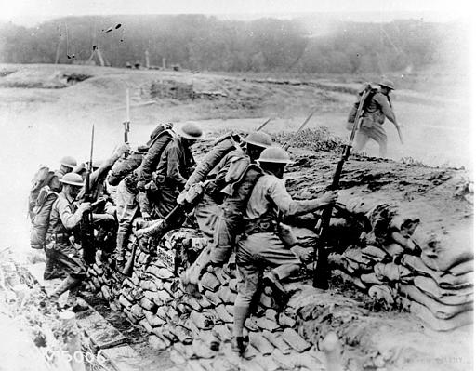

ASSESSMENT:

Criteria | Rudimentary | Developing | Proficient | Exemplary
Report | The report has issues. Supporting details and information lack detail, are typically unclear or not related to the topic. | The report is adequate. Supporting details and information are relevant, but one or more key issues have gone unaddressed. | The report is interesting and readable. Supporting details and information are clear and relevant. | The report is engaging and informative. Relevant, telling, quality details give the reader important information that goes beyond the obvious or predictable.
Visuals | Images are not clearly related to the topic and may confuse the audience. | Images are somewhat related to the topic and may contribute to audience understanding. | Images are appropriate for the topic and aid in audience understanding. | Images are perfect for the topic and enhance audience understanding.

TIMELINE:

Research Dates: ___________________________

Due Date: ___________________________

